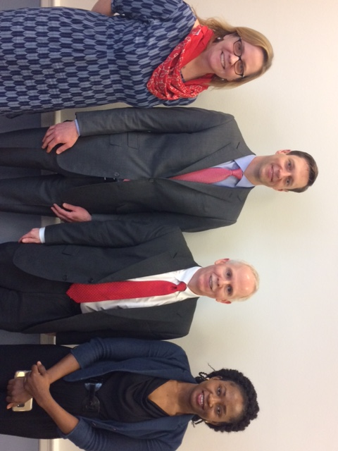

From left to right, Charlotte Colvin, PhD, Sr. Technical Advisor, Bureau of Global Health, USAID, Robert Belknap, M.D., Denver Metro TB Program, Past President, National Tuberculosis Controllers Association, Philip A. LoBue, M.D., Director, Div. of TB Elimination, National Center for HIV/AIDS, Viral Hepatitis, STD, & TB Prevention, CDC, Tanwa Owolabi, TB Survivor.

ATS Convenes World TB Day Congressional Briefing with Partners
The ATS and partner organizations including the National TB Controllers Association and RESULTS and the House Tuberculosis Elimination Caucus, co-chaired by Reps. Eliot L. Engel (D-NY), Gene Green (D-TX) & Don Young (R-AK) held a briefing in the U.S. House of Representatives to commemorate World Tuberculosis Day on March 24, 2017.

The briefing, entitled, Tuberculosis: The Leading Global Infectious Killer, featured a showing of an excerpt of the film, Breathe In, produced by Ground Media, about a young child with TB from Houston, TX and the work of her treating physician, ATS member Jeffrey Starke, M.D. along with the following speakers panel:
- Robert Belknap, M.D., with the Denver Metro TB Program, Past President, National Tuberculosis Controllers Association and ATS member
- Tanwa Owolabi, TB Survivor
- Philip A. LoBue, M.D., Director of the Division of TB Elimination at the Centers for Disease Control and Prevention (CDC).
- Charlotte Colvin, PhD, Sr. Technical Advisor with the U.S. Agency for International Development (USAID)

TB Survivor Tanwa Owolabi gave a moving testimonial about the difficulties of living with and being treated for multi-drug resistant TB. She called on Congress to support TB research and development, saying, “Too many people suffer through this long and difficult treatment, so I would like to ask Congress to support more research into TB so that we can have better shorter treatments and faster diagnostics because the waiting and not knowing what is wrong with you is very hard.” Panel moderator Robert Belknap urged Congress to support funding for global and domestic TB control and research and development through CDC, USAID, NIH and Biomedical Advanced Research and Development Authority (BARDA).

